Chapter 11, Problem 31.

Find the rms value of the signal shown in Fig. 11.62.

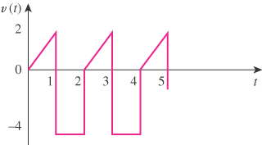

Figure 11.62
For Prob. 11.31.

